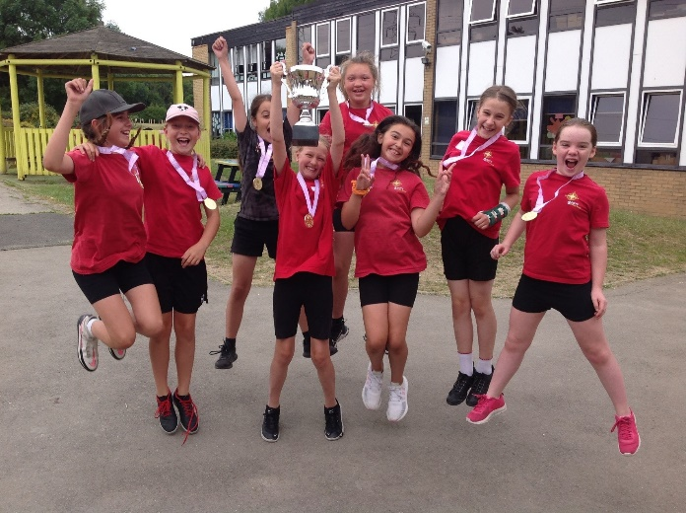
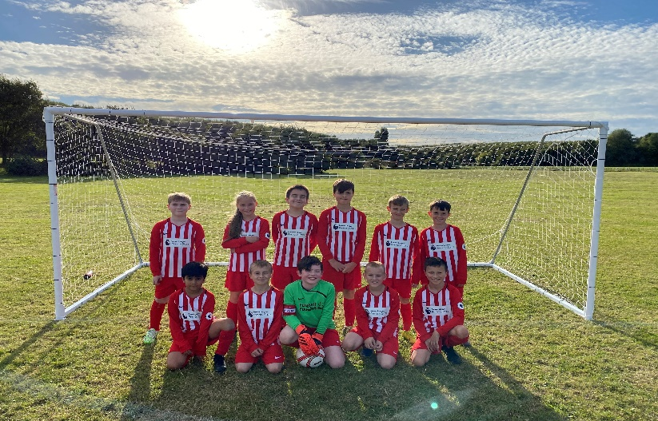
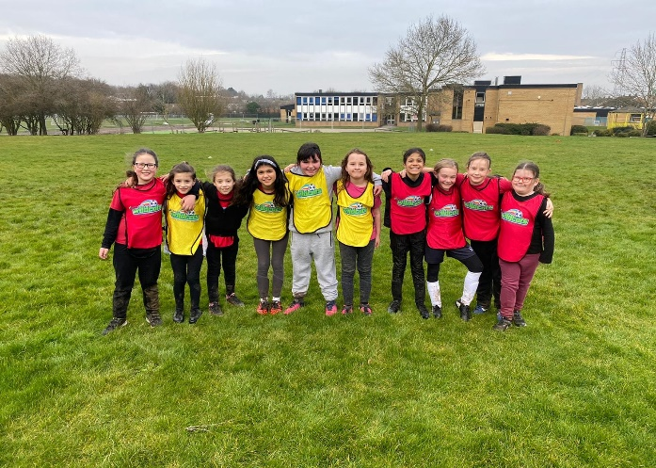
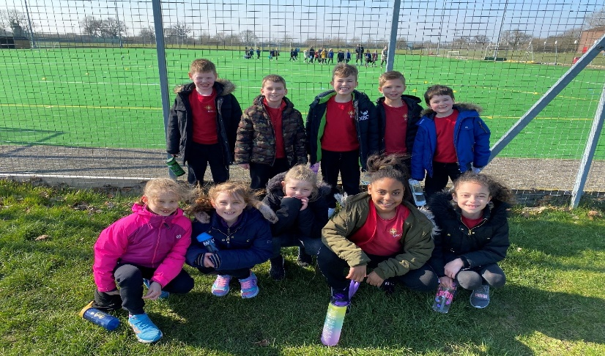
Updated July 2023
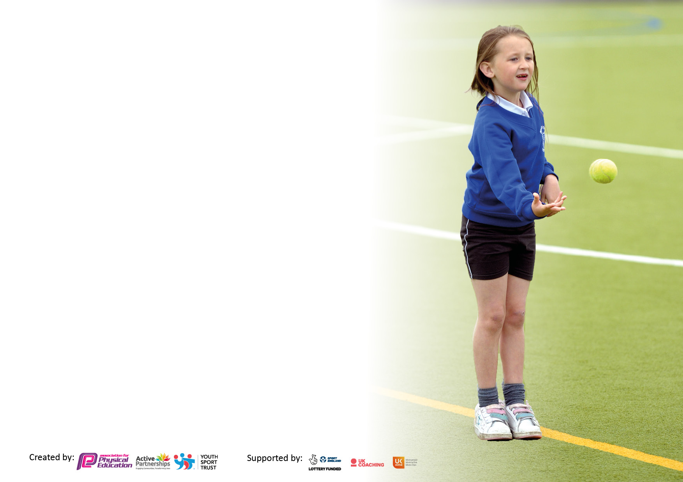

It is important that your grant is used effectively and based on school need. The Education Inspection Framework makes clear there will be a focus on ‘whether leaders and those responsible for governors all understand their respective roles and perform these in a way that enhances the effectiveness of the school’.

Under the Quality of Education Ofsted inspectors consider:
Intent - Curriculum design, coverage and appropriateness
Implementation - Curriculum delivery, Teaching (pedagogy) and Assessment
Impact - Attainment and progress

To assist schools with common transferable language this template has been developed to utilise the same three headings which should make your plans easily transferable between working documents.

Schools must use the funding to make additional and sustainable improvements to the quality of Physical Education, School Sport and Physical Activity (PESSPA) they offer. This means that you should use the Primary PE and sport premium to:

- Develop or add to the PESSPA activities that your school already offer
- Build capacity and capability within the school to ensure that improvements made now will benefit pupils joining the school in future years
- The Primary PE and sport premium should not be used to fund capital spend projects; the school’s budget should fund these.

Pleasevisitgov.ukfortherevisedDfEguidanceincludingthe5keyindicatorsacrosswhichschoolsshoulddemonstrate animprovement.Thisdocumentwillhelpyoutoreviewyourprovisionandtoreportyourspend.DfEencouragesschools to use this template as an effective way of meeting the reporting requirements of the Primary PE and Sport Premium.

We recommend you start by reflecting on the impact of current provision and reviewing the previous spend.

Schools are required to publish details of how they spend this funding, including any under-spend from 2021/2022, as well as on the impact it has on pupils’ PE and sport participation and attainment. All funding must be spent by 31st July 2023.

We recommend regularly updating the table and publishing it on your website throughout the year. This evidences your ongoing self-evaluation of how you are using the funding to secure maximum, sustainable impact. Final copy must be posted on your website by the end of the academic year and no later than the 31st July 2023. To see an example of how to complete the table please click HERE.

Details with regard to funding
Please complete the table below.

Total amount carried over from 2021/22 | £12,741.02
Total amount allocated for 2022/23 | £20,080.00
How much (if any) do you intend to carry over from this total fund into 2023/24 | £0
Total amount of funding for 2023/23. To be spent and reported on by 31st July 2023. | £32,821.02
Swimming Data
Please report on your Swimming Data below.

Meeting national curriculum requirements for swimming and water safety.  N.B. Complete this section to your best ability. For example you might have practised safe self-rescue techniques on dry land which you can then transfer to the pool when school swimming restarts.  Due to exceptional circumstances priority should be given to ensuring that pupils can perform safe self rescue even if they do not fully meet the first two requirements of the NC programme of study | Our students have a unit of swimming in the academic year, which focuses on general swimming strokes, alternative swimming strokes and rescue safety procedures.
What percentage of your current Year 6 cohort swim competently, confidently and proficiently over a distance of at least 25 metres?  N.B. Even though your pupils may swim in another year please report on their attainment on leaving primary school at the end of the summer term 2022.  Please see note above | 55%
What percentage of your current Year 6 cohort use a range of strokes effectively [for example, front crawl, backstroke and breaststroke]?  Please see note above | 25%
What percentage of your current Year 6 cohort perform safe self-rescue in different water-based situations? | 70%
Schools can choose to use the Primary PE and sport premium to provide additional provision for swimming but this must be for activity over and above the national curriculum requirements. Have you used it in this way? | No

Action Plan and Budget Tracking
Capture your intended annual spend against the 5 key indicators. Clarify the success criteria and evidence of impact that you intend to measure to evaluate for pupils today and for the future.

Academic Year: 2022/23 | Total fund allocated: £1965.71 | Date Updated:
Key indicator 1: The engagement of all pupils in regular physical activity – Chief Medical Officers guidelines recommend that primary school pupils undertake at least 30 minutes of physical activity a day in school |  |  |  | Percentage of total allocation:
 |  |  |  | %
Intent | Implementation |  | Impact
Your school focus should be clear what you want the pupils to know and be able to do and about  what they need to learn and to  consolidate through practice: | Make sure your actions to achieve are linked to your intentions: | Funding allocated: | Evidence of impact: what do pupils now know and what can they now do? What has changed? | Sustainability and suggested next steps:
In order to engage all of our students, in regular Physical Activity, our school vision needs to focus on the ability to:  1. Promote an all-inclusive environment, where our students feel they can lead healthy and active lives.  2. Encouraging a growth mind-set from our students when they approach Physical Education, School Sport and Physical Activity.  3. Embed our school values into our Physical Education Curriculum.  4. Empower all students to become physically literate: motivated, physically competent and confident in their fundamental movement skills.  5. Increase the wellbeing of the school through movement: Learning to move and moving to learn.  The students from Scott Primary must value Sport and PE. It is an area that was highlighted as a key strength in our last Ofsted inspection and is therefore something the school is very proud of.  We need to enable our students to:  • Participate in 2 hours of PE lessons a week and have 80 mins of daily outdoor play, which is structured with various activities such as: Basketball, Football and Dancing, Throwing, Chasing, Skipping and Jumping.  • We aim for all our students to know that PE and Student Well Being is valued and at the height of our interest at the school  • Staff members will aim to ensure that the students are physically active during break times and lunchtimes.  • We intend on setting up Sports Clubs that will take place during school days. | In order to achieve the intentions, the school implemented the following things:  - Clubs were set up during the school day to engage our students to be physically active and meet new friends from different year groups. 5 lunchtime clubs, set up for all ability groups.  - After school provisions were set up for students’ to enjoy. This year we provided: Tennis x2, Football x2, Rugby x2, Dance x2 and Yoga.  - Members of staff (Classroom teachers) running their own sports clubs in order to encourage the students to engage in sport. Running and Football club.  - Student Sports crews set up at school to keep younger age group students active and enjoying sport and recreation during breaktime and lunchtime.  - Whole school promotion of Well-being activities, that are done daily by class teachers.  - Wake up and shake up activities that are done throughout the day to keep students steps up and the students feeling active. | £1,630.00 SSP Sports membership  £335.71 Playground equipment North Pole  £5,388.73 Sports clubs (Tennis, Footbal, Rugby, Dance, Yoga) + equipment  £2,340 Basketball club  Outdoor learning £2,340 (staff once a week)  £30 Playground Pals badges  £5,000 line marking  £2,400 two PE sheds | The school have hit their targets in an active school approach. From the start of the day, students are on their feet and taking part in activity. Every student is part of this process and wants to have fun in being active. Students like to take part and to involve others through leadership activities. | In order to continue development in student engagement, we must push active working whenever possible.  Wake up and shake ups, after lunchtime activities and students increasing their steps in order to see the benefits of healthy body-healthy minds.  We must continue to offer sporting clubs and recreations in school. Can we look at creating more outside of school links in order to impact the school profile more.  We must push for a greater uptake in ‘Stormbreak’ sessions across the school.  We are planning a whole school behavioral plan which centers around Sport.
Key indicator 2: The profile of PESSPA being raised across the school as a tool for whole school improvement |  |  |  | Percentage of total allocation:
 |  |  |  | %
Intent | Implementation |  | Impact
Your school focus should be clear what you want the pupils to know and be able to do and about  what they need to learn and to  consolidate through practice: | Make sure your actions to achieve are linked to your intentions: | Funding allocated: | Evidence of impact: what do pupils now know and what can they now do? What has changed?: | Sustainability and suggested next steps:
A PE focused Approach to School Improvement is vital in order to keep students engagement and behavior at a high level. PESSPA being raised across the school is pivitol to our Physical Education aims and objectives.  These are the parts of our PESSPA aims that we are focusing on from this section:  1. Promote an all-inclusive environment, where our students feel they can lead healthy and active lives.  2. Encouraging a growth mind-set from our students when they approach Physical Education, School Sport and Physical Activity.  3. Embed our school values into our Physical Education Curriculum.  4. Empower all students to become physically literate: motivated, physically competent and confident in their fundamental movement skills.  5. Increase the wellbeing of the school through movement: Learning to move and moving to learn.  We want the students to be able to value PESSPA throughout their educational journey, making it a part of their day and maintaining a healthy lifestyle. | Our PESSPA approach centres around keeping the students focused and behaving to a high standard.  We implemented the following things:  - Stormbreak well being activities for every class. Teachers were there to lead these activities and they involved all of the students moving and working practically.  - Every students will be aligable to receive 2 hours of timtabled PE lessons a week.  - The School are involved in Sporting Leagues after school and during school fixtures. The school participated in every fixture and festival that they were able to attend. We aimed to take every student to a fixture.  - Physical activity is at the height of our school, where the students have a lot of space and freedom to play, during lunchtimes and breaktimes.  - Physical activity continues after school with sporting clubs that are available to every student.  - Sporting assemblies were undertaken for KS1 and KS2 to keep them active and involved in PA. | £335.71 Playground equipment for South Pole  £500 Stormbreaker Program (Paid for last academic year)  £335 Football Kits  £169 PE T-Shirts .  £1,007 Football goals  £80 Football nets  £94 Tennis Table paddles  Motivational Sports speaker £1,500 | - Students are seeing the values of being active and involving themselves in SS.  - Students are enthusiastic about appearing for the school in fixtures and festivals.  - Students talk about Stormbreaker around the school.  - Sport in school creates dialogue between the students. | More work needs to be done in this area to raise the profile. Currently we are doing a lot to try and make an impact, however I feel that we can continue to do this.  We know that the students value PESSPA, however we want it to be constantly at the forefront of their day.

Key indicator 3: Increased confidence, knowledge and skills of all staff in teaching PE and sport |  |  |  | Percentage of total allocation:
 |  |  |  | %
Intent | Implementation |  | Impact
Your school focus should be clear | Make sure your actions to | Funding | Evidence of impact: what do | Sustainability and suggested
what you want the pupils to know | achieve are linked to your | allocated: | pupils now know and what | next steps:
and be able to do and about | intentions: |  | can they now do? What has
what they need to learn and to |  |  | changed?:
consolidate through practice:
Our intent is for our staff to feel confident and comfortable when delivering Physical Education lessons and Sporting Pursuits.  We are also trying to involve Support Staff and other school collegues in sport through synergy.  Involve our governors and SLT in the promotion of sport across the board.  These are the parts of our PESSPA aims that we are focusing on from this section:  1. Promote an all-inclusive environment, where our students feel they can lead healthy and active lives.  2. Encouraging a growth mind-set from our students when they approach Physical Education, School Sport and Physical Activity.  3. Embed our school values into our Physical Education Curriculum.  4. Empower all students to become physically literate: motivated, physically competent and confident in their fundamental movement skills.  5. Increase the wellbeing of the school through movement: Learning to move and moving to learn. | In order to single our intent, the following things were implemented:  Meetings were had with individual staff to discuss and plan PESSPA lessons.  Members attended sports fixtures in order to increase their knowledge and confidence in PESSPA.  Members of staff were involved in coaching and leading training sessions for teams at school.  Staff attending sports festivals during the school day, with their classes.  Shared planning for PE lessons has been given out and discussed with members of staff.  Observations of PE lessons have been done by trainees and current staff in order to present correct practice and differentiation. | £1,500 staff dance training through BEE Creative  £700 Playground equipment for North Pole  £100 High Vis jackets for the Walking Bus  £3,000 Climbing Equipment  £300 Balance Bikes & scooters  £400 Early Years gross motor skills equipment  £4,000 MUGA goals & nets | Some members of staff have given positive feedback on how they have improved in their delivery of PE.  Staff have enjoyed going on school fixtures where they can see the benefits of inter school competitions.  Staff members have enjoyed coaching and organizing PESSPA activity such as Swimming, Dance and Outdoor Education. | In order to improve in this area. We will need to make this focus on a more wide scale with our staff members.  We should focus on staff meetings and bringing in specialist teachers and behavioral experts to project the ways that PESSPA is delivered across the Primary Spectrum.
Key indicator 4: Broader experience of a range of sports and activities offered to all pupils |  |  |  | Percentage of total allocation:
Intent | Implementation |  | Impact
Your school focus should be clear | Make sure your actions to | Funding | Evidence of impact: what do | Sustainability and suggested
what you want the pupils to know | achieve are linked to your | allocated: | pupils now know and what | next steps:
and be able to do and about | intentions: |  | can they now do? What has
what they need to learn and to |  |  | changed?:
consolidate through practice:
Our intent is for students to experience a range of known and unknown sports, in order to train different perceptions of how sports looks.  Alternative games being embedded in our PESSPA curriculum, will help students across a wide scale to appreciate sport and gain success from it.  These are the parts of our PESSPA aims that we are focusing on from this section:  1. Promote an all-inclusive environment, where our students feel they can lead healthy and active lives.  2. Encouraging a growth mind-set from our students when they approach Physical Education, School Sport and Physical Activity.  3. Embed our school values into our Physical Education Curriculum.  4. Empower all students to become physically literate: motivated, physically competent and confident in their fundamental movement skills.  5. Increase the wellbeing of the school through movement: Learning to move and moving to learn.  Additional achievements:  Year 5 Netball District Champions  Year 6 Netball District Champions  Year 5/6 Girls Football District Champions  Year 5/6 Girls Football County Champions  Year 5/6 Boys Football District League and Cup Runner-up  Year 4 Girls Scoreball District Champions  Year 4 Boys Scoreball District Champions | We added the following Sports and alternative games to our LTP, in order to broaden the experiences of PESSPA:  Dodgeball  Lacrosse  Striking and Fielding games (Made up)  Midball  Kin-Ball  Health and Fitness  Softball  Kickball  King Ball | £169 Dodgeball Equipment  £160 Basketball Equipment  £540 Diwali Dance Workshop  £500 Chinese Dance Workshop  £989 Mini bus MOT & insurance to allow children to take part in away fixtures  £500 Inspection & remedial works for outdoor play equipment | The sports/Games that we have added to our curriculum have had a great impact on the students and staff.  Students are starting to understand that sports is not just about the stereotypical games and there is far more range to PESSPA.  Students have asked to revisit these games.  Students that have found difficulties with Football and team games, have enjoyed the new challenges of a broader curriculum. | In order to develop this more, students will need to introduce more games and pilot these during lessons.  Staff members have enjoyed presenting these games and wish to develop them further.  Attending training to improve our knowledge and understanding of alternative games.

Key indicator 5: Increased participation in competitive sport |  |  |  | Percentage of total allocation:
 |  |  |  | %
Intent | Implementation |  | Impact
Your school focus should be clear | Make sure your actions to | Funding | Evidence of impact: what do | Sustainability and suggested
what you want the pupils to know | achieve are linked to your | allocated: | pupils now know and what | next steps:
and be able to do and about | intentions: |  | can they now do? What has
what they need to learn and to |  |  | changed?:
consolidate through practice:
To continue to participate in sports Leagues, Sports Festivals, SEN Festivals and during school fixtures.  Allow as many students to compete in fixtures.  Enter students that find competition difficult and make them aware that participation is the key element.  Allow our students to discuss their competitive sports acomnplishments, in the classrooms and in assemblies.  These are the parts of our PESSPA aims that we are focusing on from this section:  1. Promote an all-inclusive environment, where our students feel they can lead healthy and active lives.  2. Encouraging a growth mind-set from our students when they approach Physical Education, School Sport and Physical Activity.  3. Embed our school values into our Physical Education Curriculum.  4. Empower all students to become physically literate: motivated, physically competent and confident in their fundamental movement skills.  5. Increase the wellbeing of the school through movement: Learning to move and moving to learn. | During the school year, we have:  - Appeared in numerous fixtures, festivals and SEN Festivals.  - Commemorated students every week in assemblies.  - Congratulated our teams for their accomplishments.  - Kept notes of students that are attending teams in/outside of school in order to galvanize them.  - Encouraged students to join teams and to be healthy when competitive.  - Noticed an up rise in students that have played or trained with club teams of a range in sport. | £5 Sportsperson of the Week Award | Students feeling happy of their achievements when appearing for the school in competition.  Students knowing games better, in order to teach/coach to other peers.  Asking the PE Department to increase the student coaches due to having more knowledge in the subject areas.  Having sporting affiliations with Clubs in the community in order to increase our number of students. | Arrange more sporting trips, so that students can witness competitions and how the structure of sporting events looks.  Continue to appear in sporting fixtures in order for students to be competitive and challenge for awards and excellence.  Take part in more B and C team tournaments, for students that do not always get the opportunity to compete.  Make participation the forefront of our minds when it comes to PESSPA

Signed off by
Head Teacher: | - Barker
Date: | July 2023
Subject Leader: | Laurence Allen
Date: | July 2023
Governor: | Malcolm Redford
Date: | July 2023

