**PSHE- Long Term Plan**

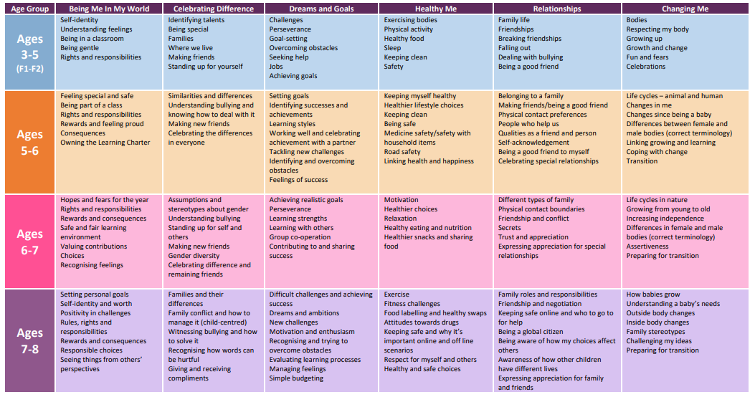

**Year 3 Year**

**Year 2 Year**

**Year 1 Year**

**EYFS**

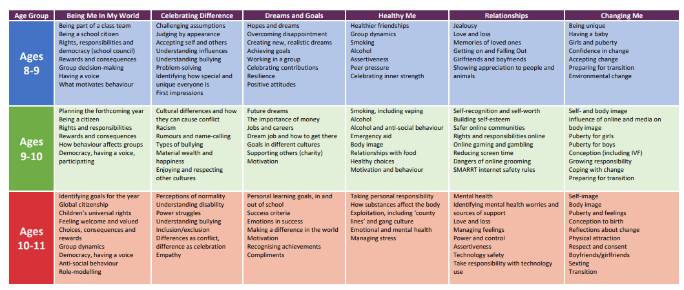

**Year 6 Year**

**Year 5 Year**

**Year 4 Year**